How to connect to your mqtt server

Introduction
The firmware installed on the device defines a fixed format for themes and subscription message formats. Default connection to the tms and emxq mqtt servers of dspread. You can quickly connect your device to your MQTT server by updating parameters through the TMS system.

TMS login
Please contact dspread to obtain tms login permission

Create Cert and Param OTA package
- About tms/CertParam/ ResourceFile/posparam.ini
posparam.ini is JSON fomart.
The following is a list of parameters that support remote updates
Param Name | Type
MqttUrl | String | MQTT server address
MqttPort | String | MQTT server port
username | String | Username for connecting to MQTT server
password | String | Password for connecting to MQTT server
clietId | String | ClientId for connecting to MQTT server  In general, no setting is required, SN is used as the client ID by default in the firmware
Topic | String | It is the base topic, and the device will  automatically append its own SN to form the final subscription topic  Example;user/message/sn
LogStatus | Int | 0: Release  2:Debug
CertState | Int | 0: No certificate needs to be set up  1: A certificate needs to be set up
- About original Cert and Param files
If set CertState with 0,
posparam.in file is needed to create CertParam_V1.0.6.zip
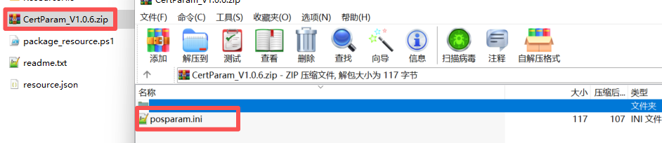
Please note that the zip file only contains the posparam.ini file Cannot contain other folders
If set CertSate with 1 posparam.iniand cert files are needed to create CertParam_V1.0.6.zip
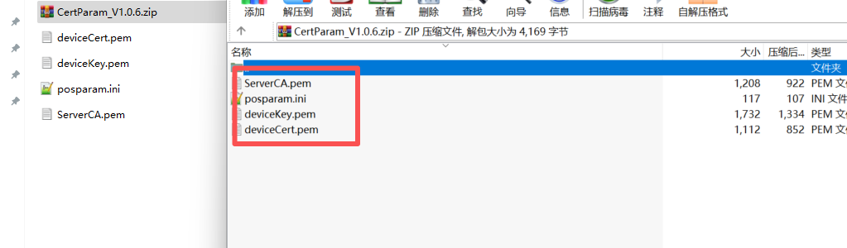
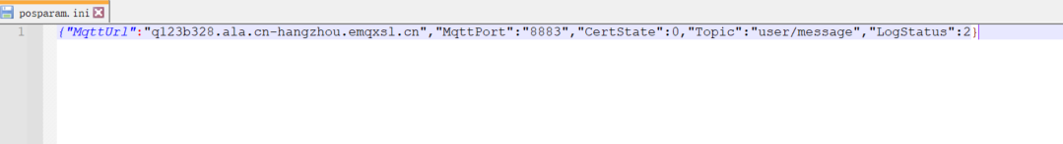
- Open powershell and run ./CertParam/package_resource.ps1
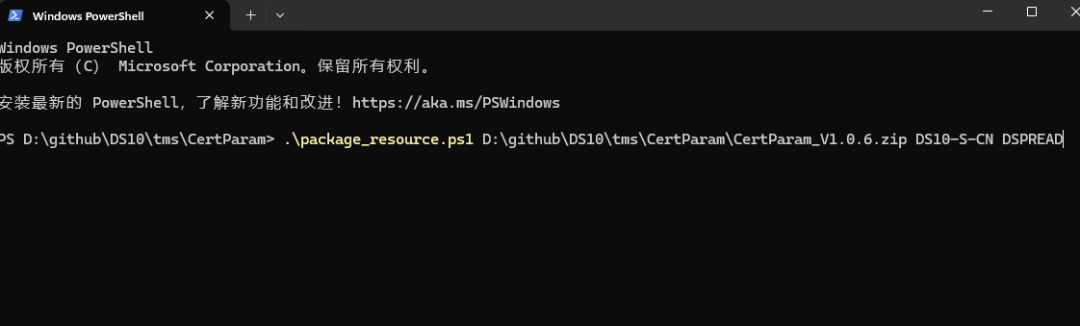
- Create Cert and Param OTA package.
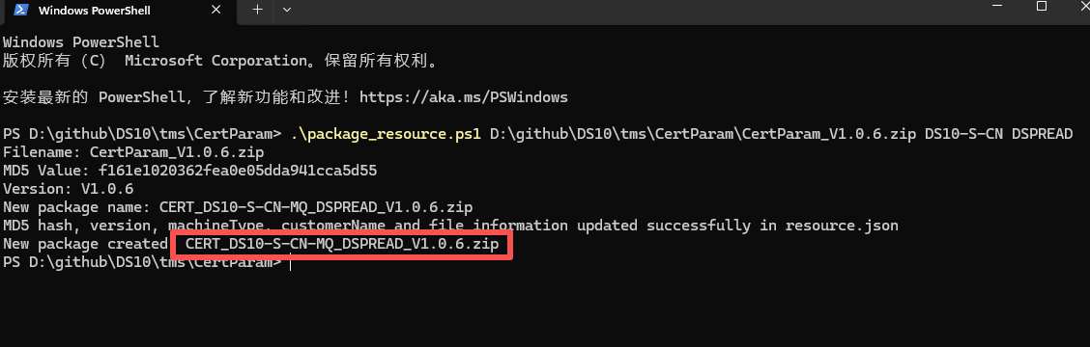

Update parameters
Please check “how to use tms.docx”

Topic and Message Format
The default firmware subscription topic and message formats are as follows.
Topic: user/message/TDS10SEU000030
Please note that TDS10SEU000030 is the device serial number, you need to modify it to your device serial number
Message Format:
{ "status": "success","orderId":"12345677","amount":1234.56 }
Please note that orderId cannot be duplicated

